**Project Report**

The project is fully working with diffuse, specular, and transmission. The final outputted results can be seen in figures 1 through 5.

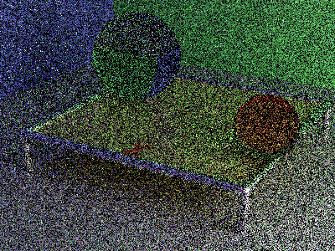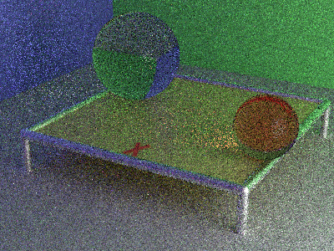

Figure 1: 1 Pass Figure 2: 8 Passes

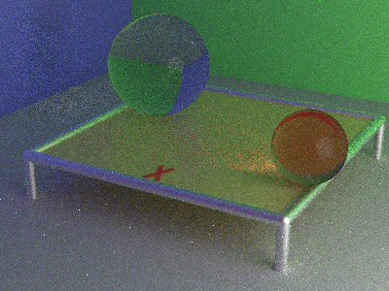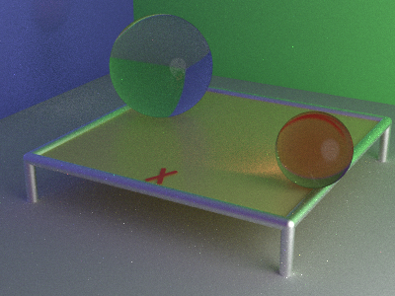

Figure 3: 64 Passes Figure 4: 512 Passes

Figure 5: 4096 Passes

For this project I had one bug that took a while to find the source of. After implementing everything from the project document I got a strange output (seen in figure 6). I also tried running the code with the spheres having no specular reflection (seen in figure 7), which wasn’t helpful in itself but helped confirm there was something wrongl. The image in figure 6 is wrong for multiple reasons. It looks as if the diffuse and specular lighting is working fine, which I confirmed by rerunning the test scene from project 3 and seeing that the output hadn’t changed. The transmission is obviously incorrect though. The spheres seem to be seen through in some way but the colors and lines are much too muddy as well as the specular white light on the spheres being too large. Also, the Y is seen on the bottom of the smaller sphere instead of the top. The smaller sphere is also not tinted red even though beer’s law is implemented.

The first thing I did was put a bunch of breakpoints into the code to try to get a general idea of what was wrong and where to direct my attention. After doing this for a while I confirmed that the dot product of omegaO and N was always positive, and the radicand was also always positive. This indicated that the bug wasn’t in the pdf or eval functions. The reason beer’s law wasn’t seen was that it was never being calculated because of the values being passed into the eval function, not because of anything wrong with the eval function itself.

This led me to believe that the sample brdf function was the issue, as this was the only other part of the code I had changed for project 4. After staring at the function for a long time and really really really not seeing anything wrong I asked for advice from you and got some good leads.

I started testing my assumptions that the output of the brdf function had to be the issue. I confirmed that the sample always went with the transmission calculation when the specular portion was removed and the chosen omegaI was always into the transmissive surface. After some more strategically placed breakpoints I realized the issue lied in my intersection calculation for spheres. I wasn’t sure so I confirmed the issue by finding a case that seemed like it should intersect the other side of the sphere but didn’t, I then copied the values of this case into a 3d grapher to prove to myself visually that there should be an intersection there. I then stepped through the intersection function until I discovered the problem. After fixing the issue so that the intersection calculation would correctly return a point on the other side of the sphere, instead of approximately the same location on the sphere, everything worked as intended.

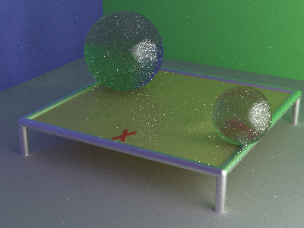

Figure 6: Broken Transmission Figure 7: Broken Transmission, No Specular

Figure 8: Intersection Graph